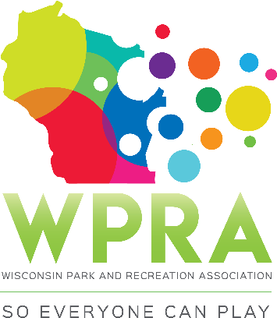

REC SECTION MEETING AGENDA
February 19, 2020
10:00 am

- CALL MEETING TO ORDER

- ROLL CALL:
Greg Lamping; Past-Chair ___ Chad Duerkop; Region 1 ___
Bridgette Hermanson; Chair-Elect ___ Adrienne Lacy; Region 2 ___
Troy Clarke; Chair ___ Ben Dayton; Region 3 ___
Megan James; Sec./Treas. ___ Maggie Anderson; Region 4 ___
Erin Russell; TR ___ Dan Zeroth; CBRSD ___
- APPROVAL OF JANUARY MINUTES

- APPROVE AGENDA

- OLD BUSINESS
- 2020 Rec Section Manual
  - Final review/approval
- Beer garden research/survey – Megan/Adrienne
- Nominating – Vacant Positions
  - Chair-Elect, Treas./Sec., Region II & Region IV Reps, CBRSD Rep
  - Due date July 31
- Section Awards
- Paperwork/submission system to be updated – Coordinate w/ Aquatics Section
- Rec Award Packet (Silver Star Awards only)
  - Need to ask permission to share all applicant’s info in a print document to be shared at the Annual Conference
- Spring Workshop
      - Presenter(s) still needed for Creative Fall & Winter Programming
      - Draft evaluation form
- Playground Workshops
- Dates/Locations 2020
- Possibly Webinar based ($50 agency fee/unlimited attendees)
      - January 30th cutoff to make Webinar idea work
- Looking at offering 1st week of June

- NEW BUSINESS
- 2020 Annual Conference – Call for Sessions
- 1-2 conference topics per committee member (16 slots to fill)
  - Conference schedule at a glance
- March 1, 2020 submission deadline
- No Scavenger Hunt – Parks coordinating fun run

- SUB-COMMITTEE REPORTS
  - BUDGET (Troy)
  - NOMINATING (Greg)
  - RULES OF ORDER (Troy)
  - SECTION AWARDS (Bridgette/Greg)
  - SPRING WORKSHOP (Troy/Greg)
  - ANNUAL CONFERENCE (Megan/Adrienne)
  - PLAYGROUND WORKSHOPS (Ben/Maggie)
  - CBRSD (Dan)

- OFFICER REPORTS
- CHAIR (Troy)
- PAST-CHAIR (Greg)
- CHAIR-ELECT (Bridgette)
- SECRETARY/TREASURER (Megan)

- REGION/WPRA REPORTS:
- REGION 1 (Chad)
- REGION 2 (Adrienne)
- REGION 3 (Ben)
- REGION 4 (Maggie)
- WPRA (Sandy)

- ANNOUNCEMENTS/OTHER MATTERS

- ADJOURNMENT

